**Exercise 3: Stored Procedures**

**Scenario 1: The bank needs to process monthly interest for all savings accounts.**

**Question: Write a stored procedure ProcessMonthlyInterest that calculates and updates the balance of all savings accounts by applying an interest rate of 1% to the current balance.**

**CODE:**

create or replace procedure processmonthlyinterest is

   bal accounts.balance%type;

begin

   for acc in (

      select accountid,

             balance

        from accounts

   ) loop

      bal := acc.balance;

      update accounts

         set

         balance = bal * 1.01

       where accountid = acc.accountid;

      dbms_output.put_line('ACCOUNT ID: '

                           || acc.accountid

                           || ', OLD BALANCE: '

                           || bal

                           || ', NEW BALANCE: '

                           ||(bal * 1.01));

   end loop;

   commit;

end;

/

EXEC PROCESSMONTHLYINTEREST;

**OUTPUT:**

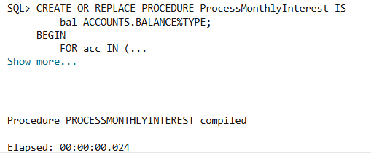

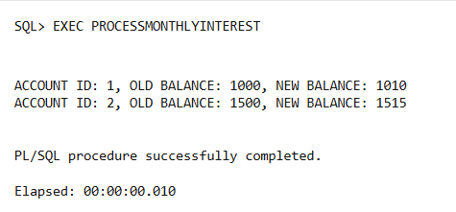

**Initial Accounts table:**

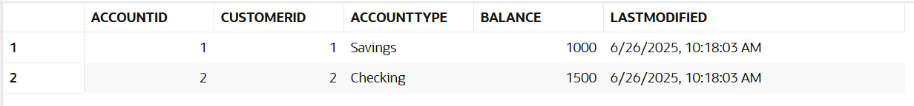

**Updated Accounts Table:**

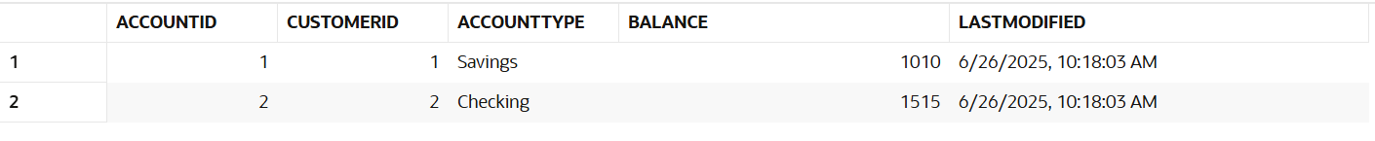

**Scenario 2: The bank wants to implement a bonus scheme for employees based on their performance.**

**Question: Write a stored procedure UpdateEmployeeBonus that updates the salary of employees in a given department by adding a bonus percentage passed as a parameter.**

**CODE:**

 CREATE OR REPLACE PROCEDURE UpdateEmployeeBonus (

bonusPercentage IN NUMBER,

deptName IN VARCHAR2

) IS

bonus employees.salary%TYPE;

sal employees.salary%TYPE;

BEGIN

FOR emp IN (

SELECT employeeid, salary

FROM employees

WHERE department = deptName

) LOOP

sal := emp.salary;

bonus := sal * (100 + bonusPercentage) / 100;

UPDATE employees

SET salary = bonus

WHERE employeeid = emp.employeeid;

DBMS_OUTPUT.PUT_LINE('Employee ID: ' || emp.employeeid ||

', Old salary: ' || sal ||

', New salary: ' || bonus);

END LOOP;

COMMIT;

END;

/

EXEC UPDATEEMPLOYEEBONUS(5, 'HR');

**OUTPUT:**

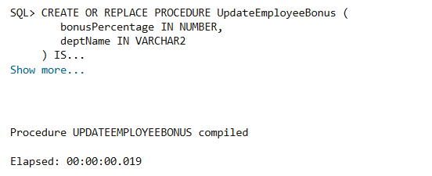

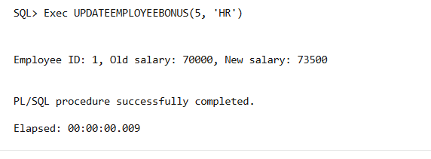

**Initial Employees Table:**

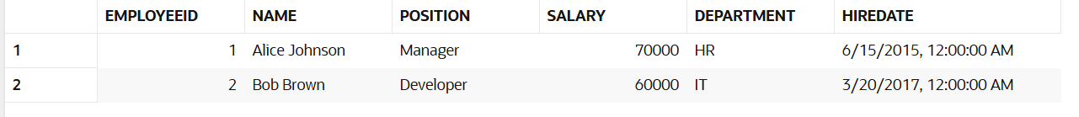

**Updated Employees Table:**

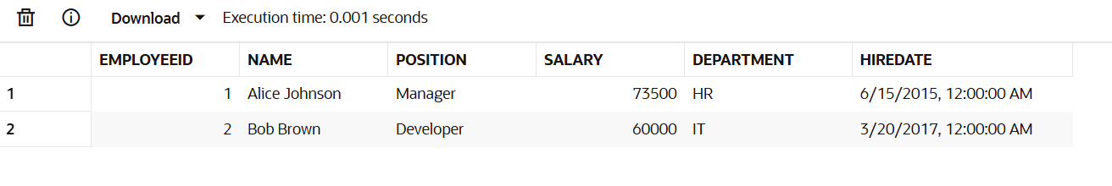

**Scenario 3: Customers should be able to transfer funds between their accounts.**

**Question: Write a stored procedure TransferFunds that transfers a specified amount from one account to another, checking that the source account has sufficient balance before making the transfer.**

**CODE:**

CREATE OR REPLACE PROCEDURE TransferFunds (

from_account_id IN NUMBER,

to_account_id IN NUMBER,

amount_to_transfer IN NUMBER

)

AS

from_balance NUMBER;

to_balance NUMBER;

BEGIN

SELECT balance INTO from_balance

FROM Accounts

WHERE AccountID = from_account_id

FOR UPDATE;

IF from_balance < amount_to_transfer THEN

RAISE_APPLICATION_ERROR(-20001, 'Not enough balance to complete the transfer.');

END IF;

SELECT balance INTO to_balance

FROM Accounts

WHERE AccountID = to_account_id

FOR UPDATE;

UPDATE Accounts

SET balance = balance - amount_to_transfer,

LastModified = SYSDATE

WHERE AccountID = from_account_id;

UPDATE Accounts

SET balance = balance + amount_to_transfer,

LastModified = SYSDATE

WHERE AccountID = to_account_id;

INSERT INTO Transactions (

TransactionID, AccountID, TransactionDate, Amount, TransactionType

) VALUES (

Transactions_seq.NEXTVAL, from_account_id, SYSDATE, amount_to_transfer, 'Withdrawal'

);

INSERT INTO Transactions (

TransactionID, AccountID, TransactionDate, Amount, TransactionType

) VALUES (

Transactions_seq.NEXTVAL, to_account_id, SYSDATE, amount_to_transfer, 'Deposit'

);

COMMIT;

EXCEPTION

WHEN OTHERS THEN

ROLLBACK;

   RAISE;

END;

/

**OUTPUT:**

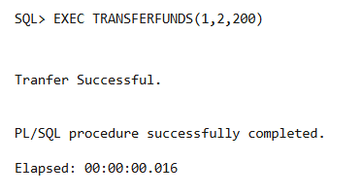

**Initial Accounts Table:**

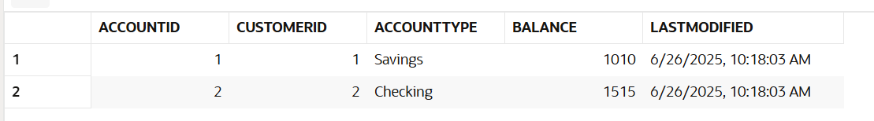

**Modified Accounts Table:**

